DI 1016 Introduction to Ecology and Landscape Design – Assignment 02

Mountain landscape in central hill in Sri Lanka-Horton Plainss

1. Introduction
Prospect and Refuge Theory was introduced by Jay Appleton in 1975. This theory explains why people prefer certain types of landscapes. According to Appleton, humans feel most comfortable in places where they can clearly see what is happening around them (prospect) while also having some form of protection or shelter (refuge).This idea comes from human evolutionary history. In the past, early humans needed open areas to see danger from far away, but they also needed protected spaces to hide and feel safe. Because of this instinct, people today are naturally attracted to landscapes that combine openness and enclosure.
In landscape architecture, designers use this theory to create spaces that feel safe and relaxing. Open viewpoints and elevated areas provide prospect, while trees, rocks, and shaded areas provide refuge.
This report discusses how Prospect and Refuge Theory can be observed in the mountain landscape of Horton Plains in Sri Lanka.

2. Location of Horton Plains
Horton Plains is located on the southern plateau of the central highlands of Sri Lanka.The peaks of Kirigalpoththa (2,389 m) and Thotupola Kanda (2,357 m).The park's elevation ranges from 1,200–2,300 m. The climate is cool, and the area is often covered with mist in the morning. Strong winds can be felt especially near open grasslands and cliff edges.
The landscape of Horton Plains includes:
- Wide open grasslands
- Dense cloud forests
- Baker’s Falls
- World’s End viewpoint

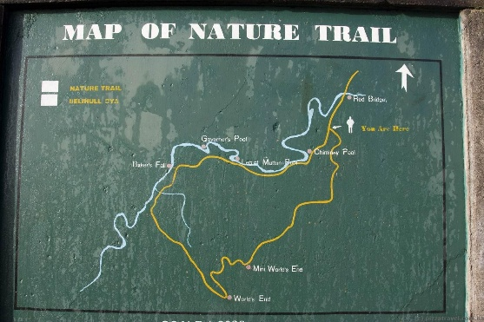

3. Experience and Landscape Analysis

3.1 World’s End (Prospect Condition)
World’s End is one of the most famous viewpoints in Horton Plains. It has a vertical drop of about 870 meters. From this point, there is a wide view of valleys, distant mountains, and the open sky.
When I reached World’s End, I felt a strong sense of openness. The landscape looked very large and powerful. I could see very far into the distance. This clearly shows prospect, because the place provides long-distance visibility and a high viewpoint.
However, I noticed that people do not stand very close to the edge for a long time. Most visitors stand slightly away from the cliff or near small rocks and shrubs. These natural elements give a small feeling of safety.
Even in a very open space, people still look for some protection. This shows how humans naturally prefer a balance between seeing the landscape and feeling safe.
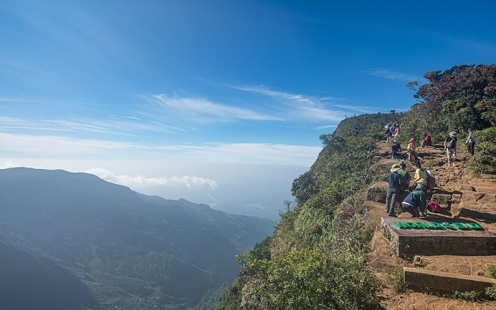
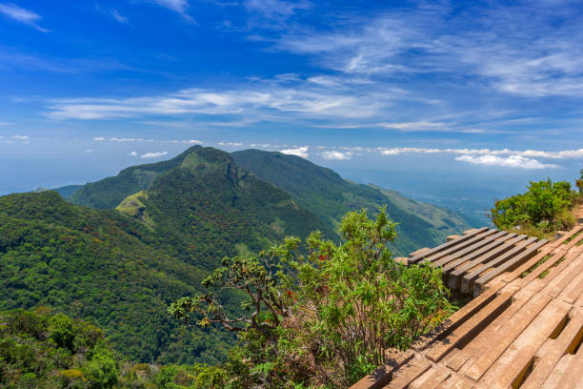

3.2 Open Grasslands (Extended Prospect)
Apart from World’s End, Horton Plains has large open grasslands. These areas are flat and wide with very few obstructions.
While walking through the grasslands, I could see far in all directions. The sky felt very open and large. The wind moved freely across the plains. This created a feeling of exposure but also freedom.
These grasslands represent prospect because they allow clear visibility of the surroundings. In the past, open areas helped humans identify danger from far away.
However, standing in the middle of the grassland for a long time can feel slightly uncomfortable because there is no shelter from wind or sun. This increases the need for nearby refuge spaces.
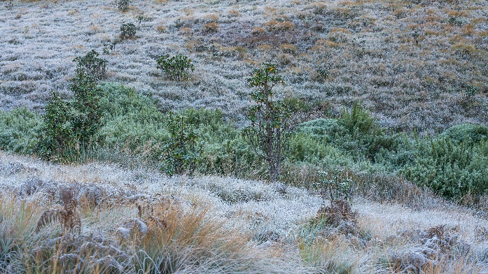
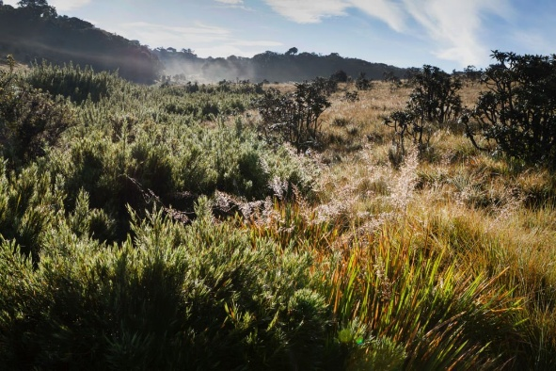

3.3 Cloud Forest Trail (Refuge Condition)
Before reaching the open viewpoints, the walking trail goes through dense cloud forest. This area feels very different from the grasslands.
Inside the forest:
- Trees form a canopy above.
- The space feels enclosed.
- Visibility becomes limited.
- Wind and sunlight are reduced.
When walking through this forest, I felt sheltered and protected. The trees surround the path and create a calm atmosphere. This clearly represents refuge.The forest gives both physical protection from wind and sun and psychological comfort. Even though visibility is limited, it feels safe and quiet.
There are also small gaps between trees where I could see parts of the plains or sky. These small openings give moments of prospect while still being inside a refuge space.

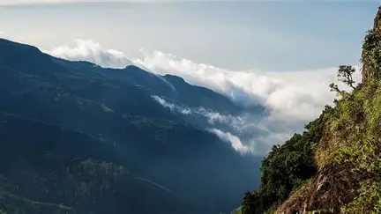

3.4 Effect of Mist
Mist plays an important role in Horton Plains. In the morning, mist sometimes covers the valley and grasslands.
When mist is present, visibility becomes limited. The landscape feels more enclosed and mysterious. This reduces prospect and increases the feeling of refuge.
When the mist clears, the wide view suddenly appears. This strong change makes the experience more dramatic and memorable.
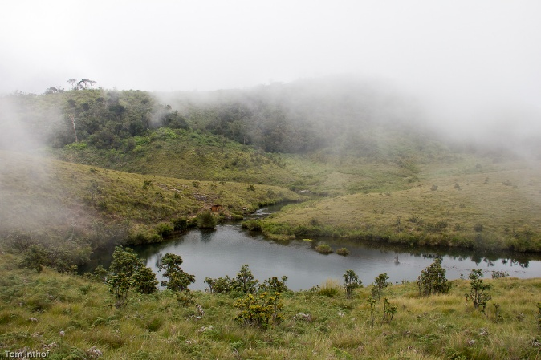

4. Conclusion
Horton Plains clearly shows the ideas of Prospect and Refuge Theory. The open grasslands and World’s End provide strong prospect because they offer wide views and elevated positions. The cloud forests provide refuge through enclosure, shade, and protection.
The most powerful experience happens when moving from forest refuge to open prospect. This transition creates emotional contrast and makes the landscape interesting.
Horton Plains is therefore a very good example of how natural mountain landscapes in Sri Lanka follow Appleton’s theory. The balance between openness and shelter makes visitors feel both excited and comfortable.

5. References
Appleton, J. (1975). The Experience of Landscape. London: Wiley.
Appleton, J. (1984). Prospects and refuges revisited. Landscape Journal, 3(2), 91–103.
Beatley, T. (2016). Handbook of Biophilic City Planning & Design. Island Press.
Van der Ryn, S., & Cowan, S. (2007). Ecological Design. Washington, DC.
Van der Ryn, S. (2013). Design for an Empathic World.

